Data Exploration

Exploration of technical attributes
Our consolidated dataset contains ~61K pictures. We already saw that they came from different sources. So we must assume that they are not standardized. We need to understand whether this results into specific modelling requirements. The exploration therefore starts with an analysis of their technical attributes followed by an analysis on the semantic content.

Image exensions
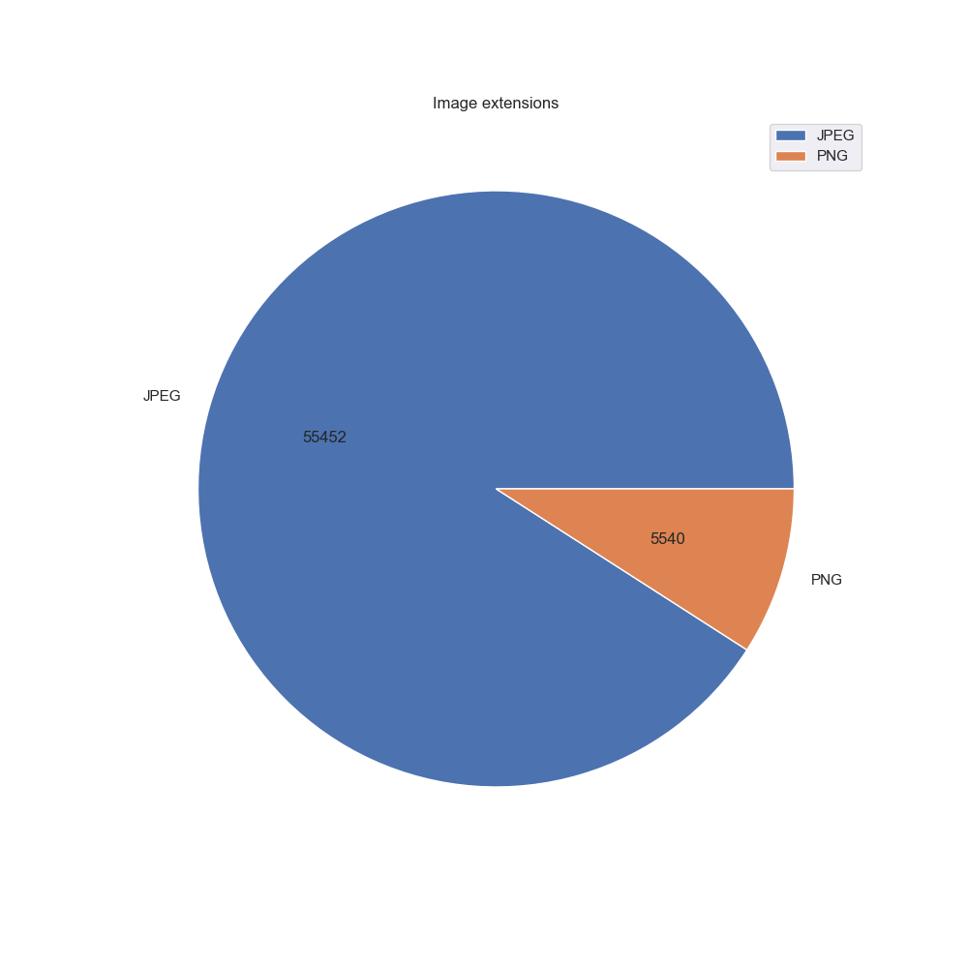
As already seen, the data comes with different image extensions. The majority of the data is in JPEG format while a smaller part is in the format PNG. The two formats are quite similar as both can support up to 16 million colors. Also both formats use compression. The main difference however is that the PNG format is using lossless compression while the JPEG format is using lossy compression. Still the JPEG format is commonly used especially for photography.
We will check during the modelling phase whether there is a relevance from having these different formats.

Mode of images
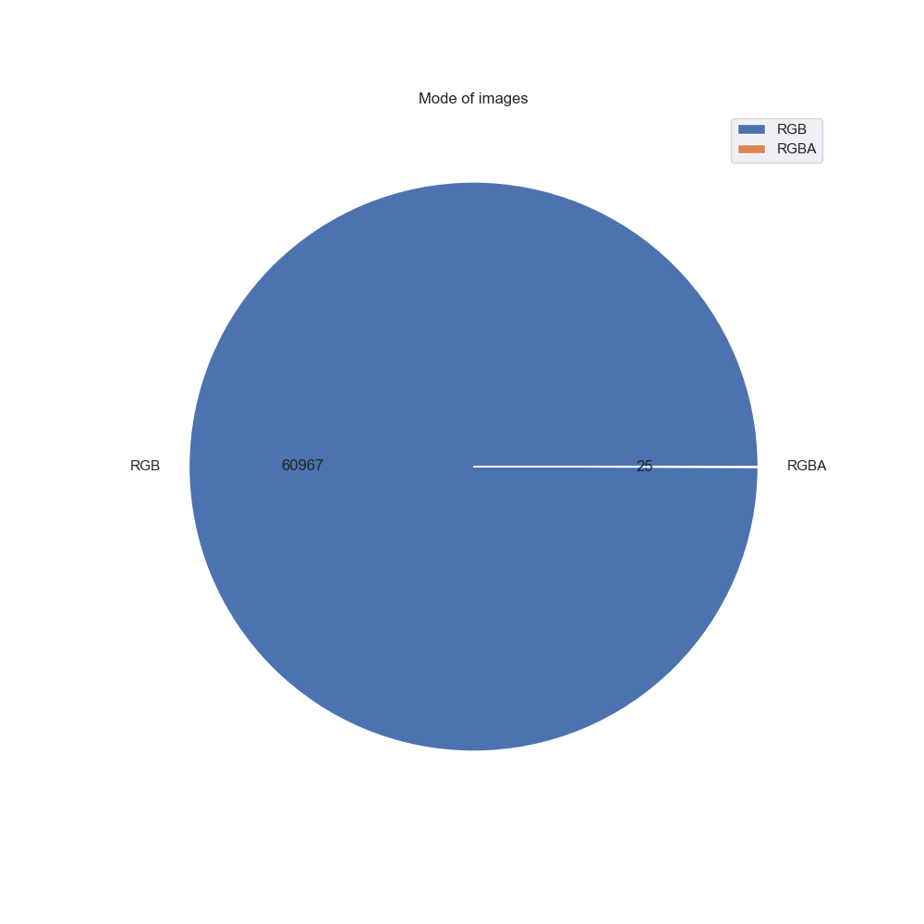
Almost all pictures have mode "RGB". However there is a handful exceptions with pictures of mode "RGBA".
The difference is that "RGB" is a 3-channel format while "RGBA" has 4 channels. This means that we will need to support both modes. However, as the number of "RGBA" pictures is very low, there would also the option to discard them from the dataset.
We will check this in the modelling phase of the project

Shape (With and Height) of images

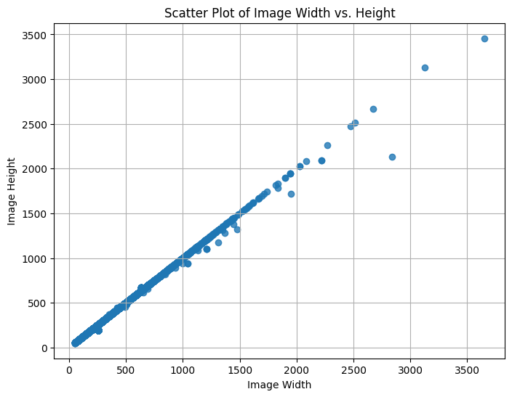
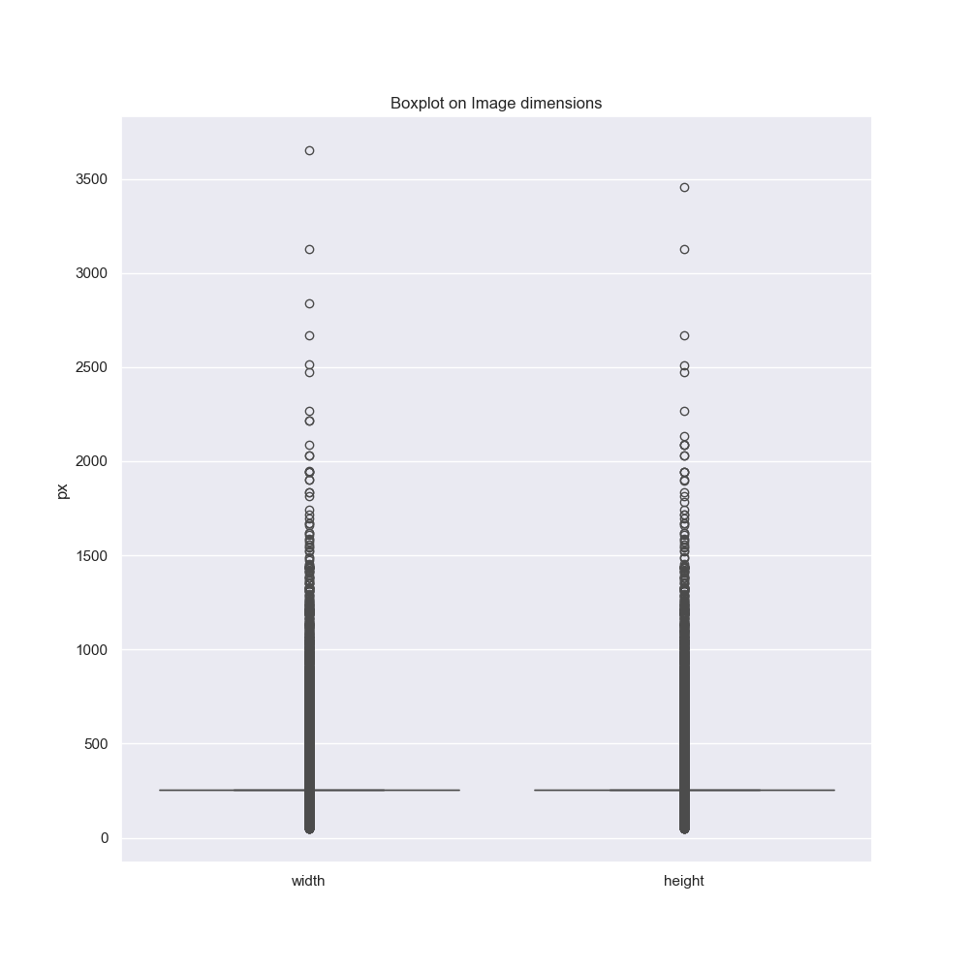
As we can see there is a wide range of shapes on the pictures. The analysis shows that most of the pictures are square, but there are exceptions.
Also we see from the boxplot that the vast majority of the pictures has a size of ca. 250 x 250. However there are several extreme values outside of the IQR (inter quartile range) of this data range.
We may need to assume that we will need to use harmonized shapes in the data model. That would mean that we would need to apply a related harmonization step for the data.

Exploration of picture semantics
In parallel to the technical attributes we also analyze the semantic content of the pictures.

Plants in the dataset
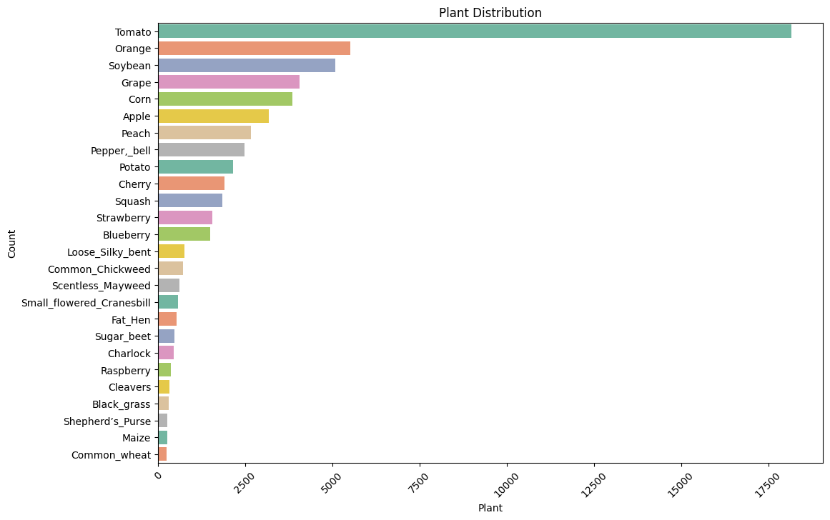
We start with analyzing the different plants that are available in the dataset. In total we have 26 different plants. The most prominent plant is the tomato which represents almost 30% of the dataset.
We will check during the modelling phase whether this uneven distribution generates an impact.

Diseases in the dataset
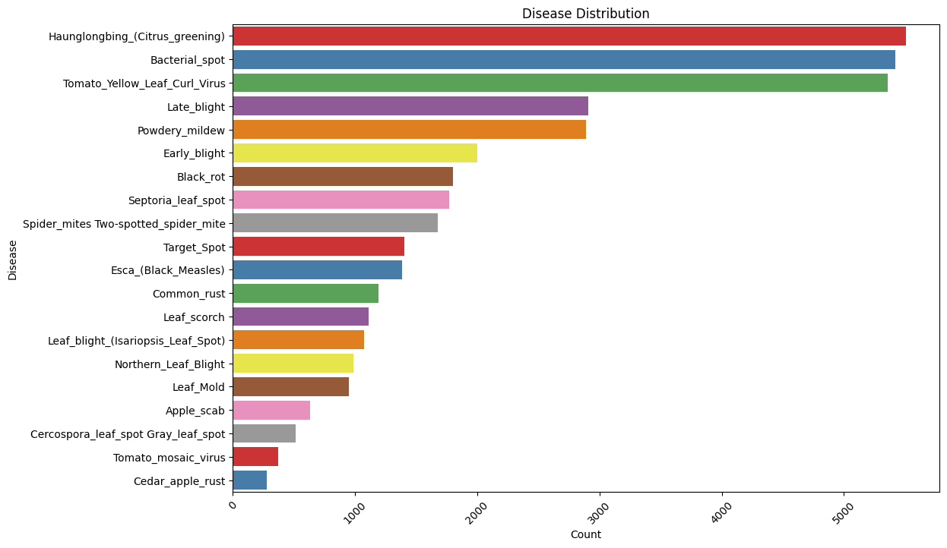
In total our dataset shows 20 different type of diseases. The distribution by disease is also quite different and this also may have an impact on the model.

Distribution of healthy vs unhealthy plants

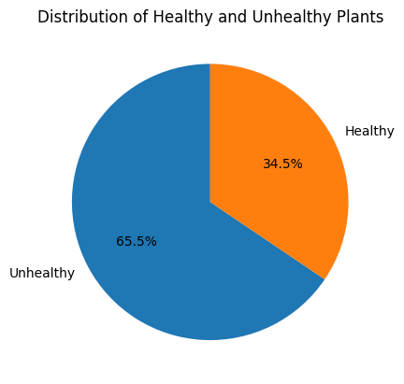
Our dataset contains pictures of healthy and of unhealthy plants. Around 2/3 of the pictures show unhealthy plants. Means that there is ca. 1/3 of the dataset related to plants classified as healthy.

Pairplot

